PANGANI GIRLS’ HIGH SCHOOL
POST MOCK 2019
Kenya Certificate of Secondary Education (KCSE)
September 2019

MARKING SCHEME

PHYSICS
Paper 1

SECTION A (25 MARKS)
- It is observed that diffusion is faster in gas than in liquid. (2marks)
In gases particles have low density,√1 high kinetic energy and low cohesion force than liquids√1
- The length of the spring is 20.0cm. It becomes 24.0cm when a weight of 8.0N hangs on it. Calculate the length of the spring when supporting a weight of 200N. (2marks)
8.0 N produces a stretch of 4.0 cm
1.0 N produces a streach of 4.0/8 = 0.5cm√1
200N produces an extension of 200x 0.5 = 100cm
Length of the spring = 100+20.0cm = 120.0cm√1
- The figure below shows the instrument used to measure pressure

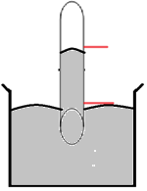
X
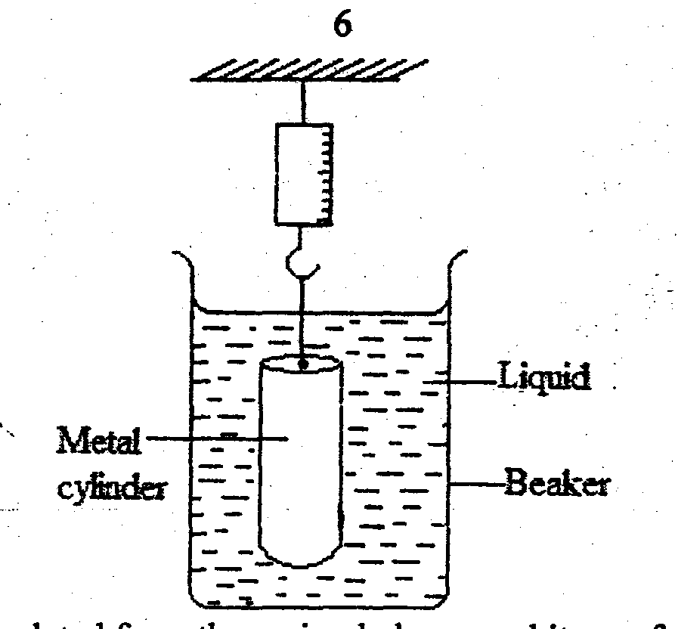

  - Name the instrument (1mark)
Mercury barometer√1
  - What would be the effect on the length X if the test tube is tilted assuming the instrument is functioning normally (1mark)
X-increase√1

- The rate of heat flow in thermal conductivity increases with increase in cross-section area. Explain this observation (1mark)
The conducting number of electrons per unit length of the thicker metal rod is more than thinner metal rod √1
- Explain why a small car travelling at a very high speed is likely to be dragged into a long track travelling in the opposite direction (2marks)
Air in between the car and the track moves with a very high speed reducing the pressure between them√1 and atmospheric pressure from sides pushes them together √1and therefore increasing chances of accidents
- A uniform meter rule is balanced by two masses as shown in the figure below.
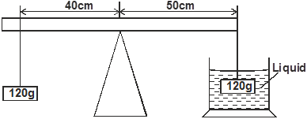

125g

By displacement method, the immersed object is found to occupy 13.5cm³. Determine the density of the liquid in SI units. (3 marks)
Clockwise moments = anticlockwise moments
1.25 X 0.5 = (U X0.5) + 1.2 X 0.4
0.625 = 0.5 U + 0.48
U = 0.625 – 0.48
0.5
= 0.29√1
U = Vpg
0.29 = 13.5 X 10 ⁻⁶ X p X 10√1
P = 0.29
13.5 X 10 ⁻⁶X10
= 2148.15 Kg/m³√1
- The springs shown in the arrangement in figure 4 below are identical.

180N

Given that the 180N weight causes a total extension of 30cm, determine the spring constant of each spring.
F=Ke √1 (3 marks)
e_{T} = e₁+e₂
0.30 = 180/3k + 180/2k√1
K = 500N/M√1
- i) Distinguish between elastic collision and inelastic collision. (1 mark)

In an elastic collision both momentum and kinetic energy are conserved while inelastic collision only momentum is conserved √1
ii) State the energy transformation during inelastic collision. (2 marks)
Heat√1______sound ______light √1
- State the branch of physics that deal with kinetic energy of matter. (1 mark)

Thermodynamics √1
- The water in a burette is 30.6cm³, 50 drops of water each of volume V are added to the water in the burette. The final reading of the burette was 20.6cm³. Calculate the radius of the drop of water .
(3 marks)

30.6 – 20.6 = 10cm³√1
Volume of drop of water = 10/ 50 = 0.2cm²√1
Volume of sphere = 4/3 лr³
0.2 cm3 = 4/3 лr³
r= 0.3627cm√1

- State two factors that affect the stability of an object (2 marks)

  - Area of the base√1
  - Position of centre of gravity√1
- State a reason why a burn from steam at 100⁰cis more severe than a burn from boiling water at the same temperature (1 mark)
Steam at 100⁰c has more energy because it has latent heat of vaporization as opposed to water at 100⁰c which does not poses latent heat of vaporization√1
SECTION B: (55 MARKS)

- a) An astronaut in orbit round the earth may feel weightless even when the earth’s gravitational field still acts on him. Explain (2 marks)

Gravitationalforce of attraction between the Astronaut and earth provides centripetal force.√1 For the astronaut to move round orbit then gravitational force must be equal to centripetal force.√1
b) Distinguish between angular velocity and linear velocity (1 mark)
Angular velocity is the rate of change of angular displacement while linear velocity is the rate of displacement.√1
c) a stone is whirled with uniform speed in a horizontal circle of radius 15 cm. it takes the stone 10 seconds to describe an arc of length 4cm. calculate
i) Angular velocity (3 marks)

ώ = Δϴ/ Δt√1
= 0.02667/10√1
= 0.002667rad/sec√1
ii) Linear velocity of the stone (2 marks)
v =r ώ√1
= 0.15 X 0.002667
= 0.0004 m/s√1
iii) Periodic time (2 marks)
T = 2л/ ώ√1
= 2л/0.002667
= 2355.9 sec√1

- a) State the Bernoulli’s principle of fluids (2 marks)

In a streamline flow of a non- viscous and incompressible fluid, an increase in its velocity produces a corresponding decrease in pressure it exerts.√1
b) In derivation of equation of continuity in fluids, state two assumptions to be made. (2marks)
    - the fluid flows steadily√1
    - incompressible√1
    - Non- viscous

c) The figure below shows cross-section of two submerged bodies P and Q in an ocean. The bodies were then pulled by a ship in the direction shown.

- State with a reason, which body is easier to pull if they have equal volume and density (2 marks)
A – less opposed to the flow √1
- Requires less effort√1

- On the same diagram, show the path followed by each body and their streamlines (2 marks)

c) Water flows steadily a pipe as shown in the figure below. The diameter of A and B are 3cm
and 5cm. if the volume flux at A is 45cm³/s. find the speed of water at B.(3 marks)
A
B

A₁V₁= A₂V₂
Velocity at B (V₂) = (5² X45)/3²
= 125cm³/sec
- a) State the law of floatation (1 mark)

A floating body displaces its own weight on the fluid in which it floats on

b) The diagram below shows a hot air balloon tethered to the ground on a calm day. The balloon contains 1300cm³ of hot air of density 0.82 kg/m3. The mass of the material making the balloon without hot air is 420kg. The density of the surrounding air is 1.35 kg/m³. Determine
Hot air

i) The total weight of hot air balloon (3 marks)

W= 1300 X 0.82 X 10 + 420 X 10
= 10660 + 4200
= 14860
- The weight of air displaced by the balloon (2 marks)
W = pVg
= 1.35 X1300 X10
= 17550N
- Upthrust force on the balloon (1 mark)

Upthrust = weight of air displaced
= 17550N

- the tension in the rope holding the balloon in the ground. (2 marks)
T = U – W
= 17550 – 14860
= 2690N

- the acceleration with which the balloon begins to raise when released.(3marks)
F = M a
2690 = 1486 kg X a
a = 1.8102 m/s²

- a) the graph below represents a body moving with variable speed

on the same graph sketch the results of the same body moving at a lower velocity.(1 marks)
b) A paper tape was attached at a moving trolley and allowed to run throw a ticker timer. If the frequency of the tape is 100Hz. Determine
i) Velocity AB and CD (4 marks)
velocity AB = 1.5 = 30cm/s
5 X 0.01
Velocity CD = 3.2 = 106.67 cm/s
3 X 0.01
ii)The average acceleration (3 marks)
a= (V – U)/ t
= (106.67 – 30) / (14 X 0.01)
= 547. 64 cm/s²
iii) The period of the ticker timer (2 marks
T = 1/f = 1/100
= 0.01 sec
- a)Figure 9 shows a set up to investigate one of the gas laws. All equipment are standardized.
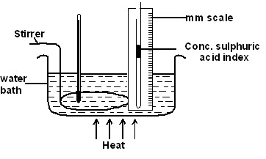
Thermometer

i) Name the gas law being investigated. (1 mark)
Charles law
ii) Give two reasons for using the concentrated sulphuric acid index. (2 marks)
  - to trap air
  - to dry the air
iii) What is the purpose of the water bath? (1 mark)
To warm / heat the trapped air
iv) State two measurements that should be taken in this experiment. (2 marks)
- length / volume of air
- temperature of the water bath or trapped air
v) Explain how the measurements taken in (iv) above may be used to verify the law. (3 marks)
- draw the graph of volume / length of the trapped air against absolute temperature
- the graph is a straight line
- the graph shows the volume is directly proportional to the absolute temperature
b) A gas has a volume of 30cm³ at 18ºC and normal atmospheric pressure. Calculate the new volume of the gas if it is heated to 54ºC at the same pressure. (3 marks)
V1/T1 = V2/ T2
V2 = 30 X327
291
V2 = 33.71 cm³

